2018-19 FIRST Robotics Grant
Michigan Electronic Grants System Plus (MEGS+)

Step 1. Log-in to MEGS+
Note: If you do not have a MEIS ID, log-in, or password visit: https://www.michigan.gov/mde/0,1607,7-140-5236_29341---,00.html

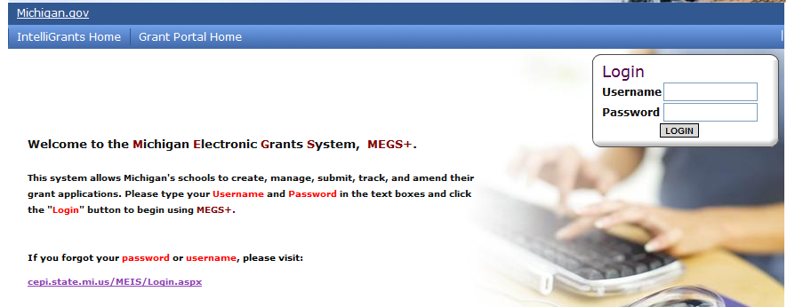
Step 2. Click view available Applications/Tasks

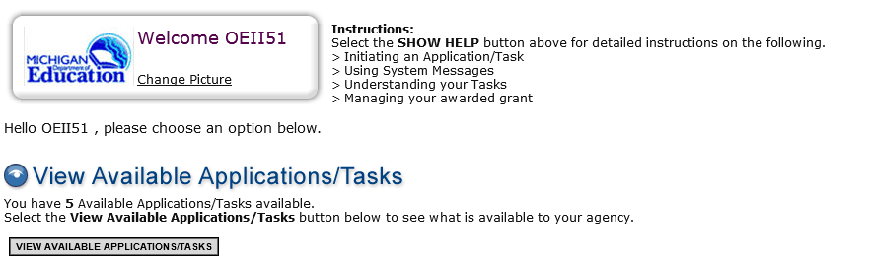

Step 3. Initiate the Application and Agree

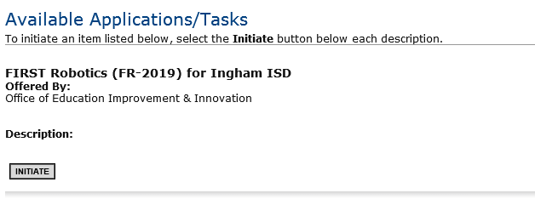
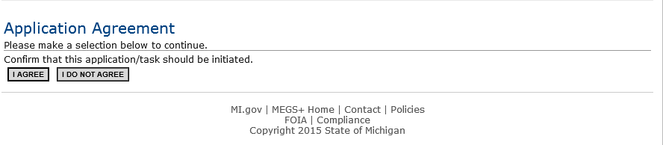

Step 4. View and Edit Application
- Click View and Edit

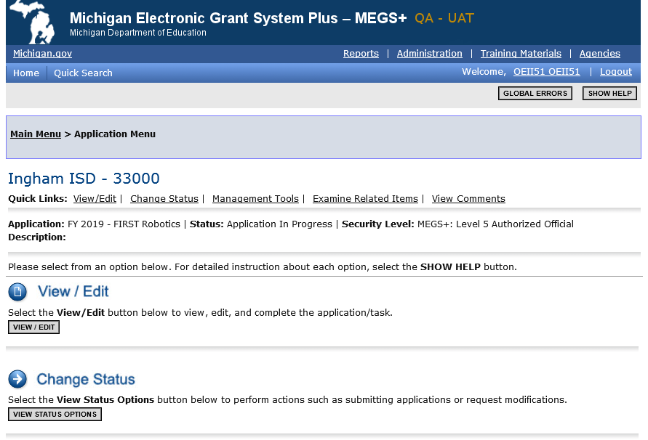

b. Review Cover Page, Assurances and Certifications, and Important Information

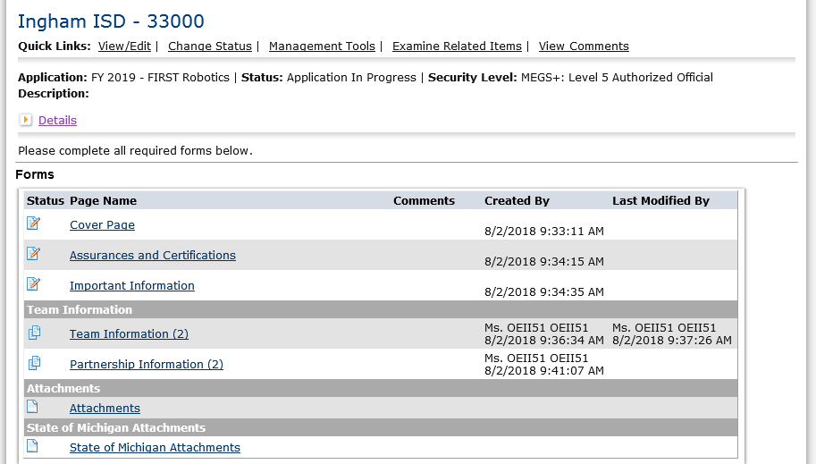

Nonpublic Schools Only: complete the competition selection page prior to completing step 4.c (Team Page).
Public School Applicants will not see this link on the view/edit page.

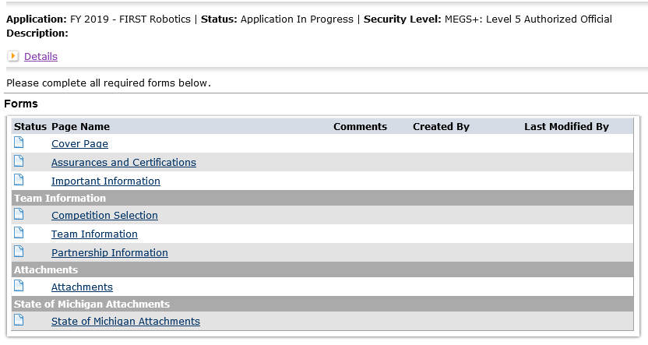
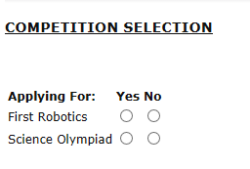

c. Complete Team Information Page
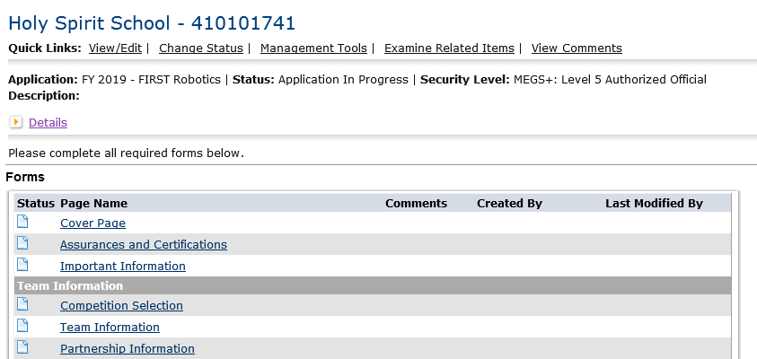
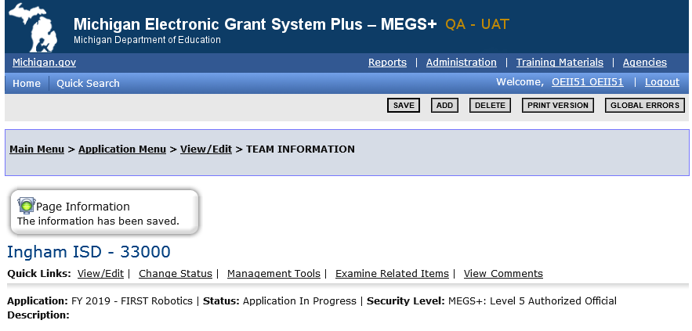
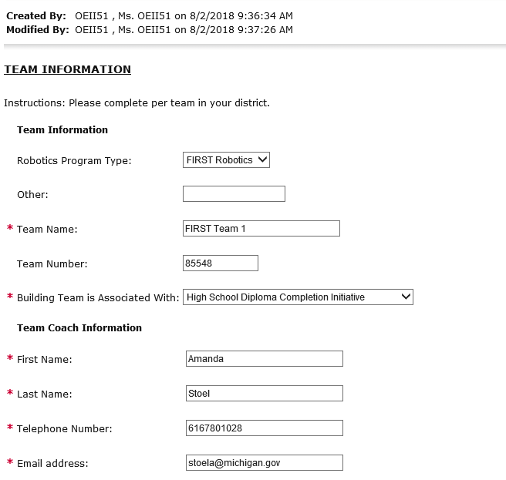
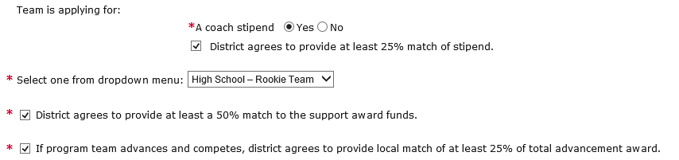
If Yes, you must agree to provide the match. Indicate acknowledgment by checking the box. If no, then do not check the box.

d. Complete Partnership Information
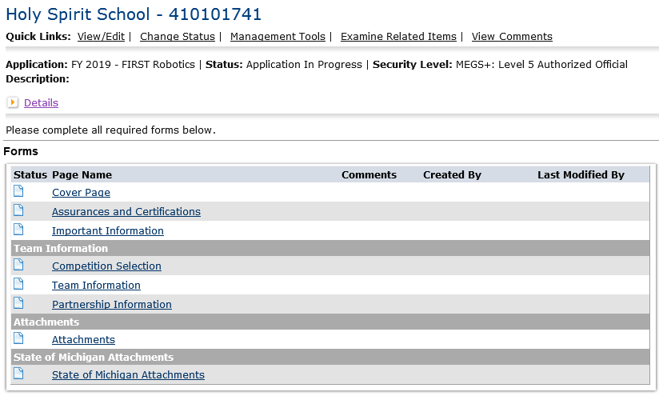
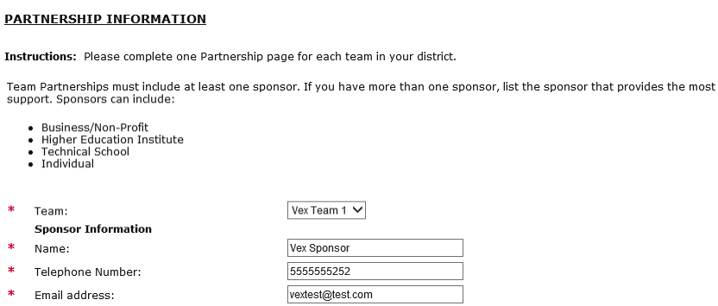
Complete the Team Page first in order to generate the dropdown options.

e. Upload Attachment
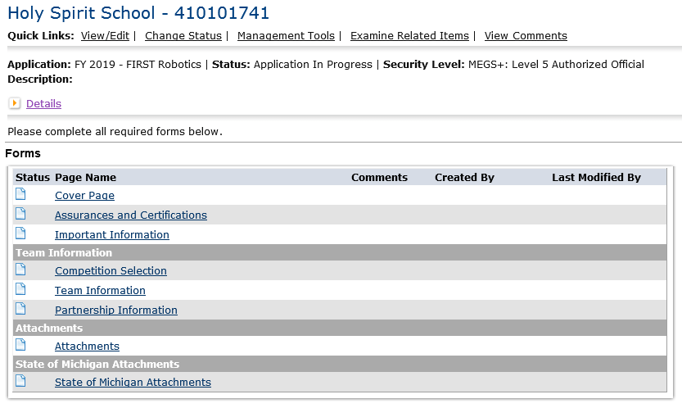

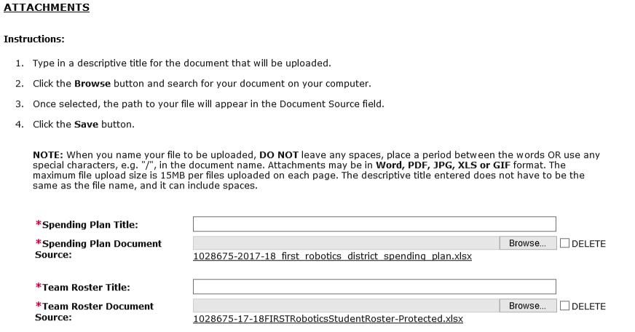
Step 5. Add Main Contact
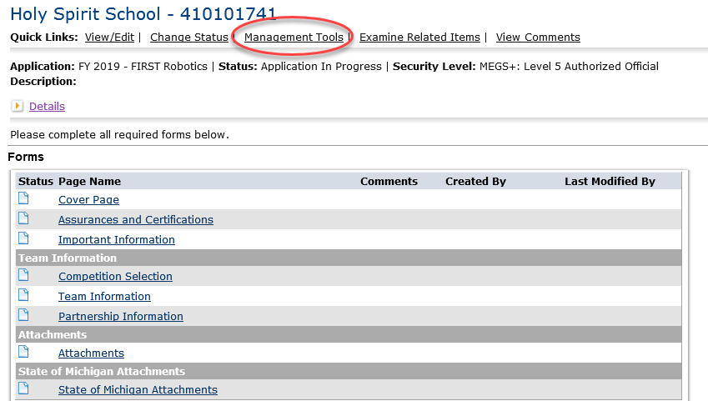
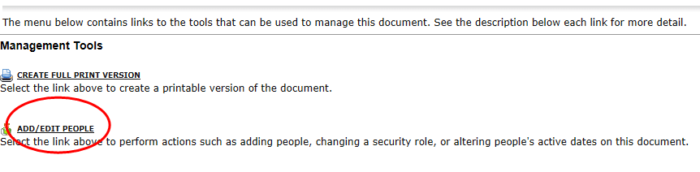
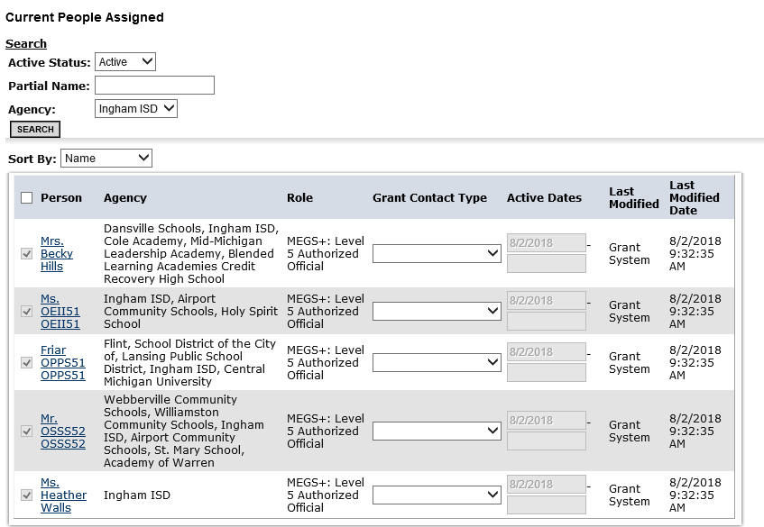

Step 6. Check for Global Errors
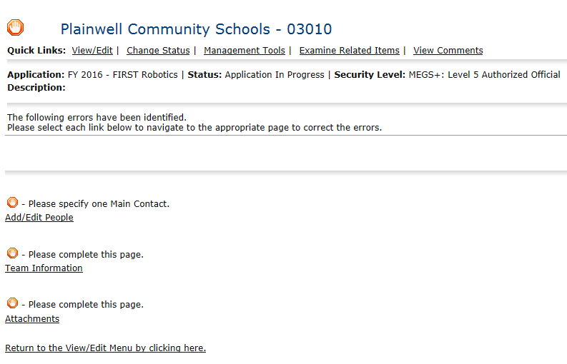
Step 7. Submit the Application
